Hotel Reservation Form Deadline: Nov.2, 2012
Please read carefully when fill in this reservation form. * is required field.
* Prefix: □Mr. □Ms. □Mrs. * Last Name / First Name: /
* Company Name:________________________________________ * Mobile : ______________________________
* Tel/Fax: _______________________________________________ * Email:_______________________________

* Arrival Date:________________________________ * Departure Date:__________________________________
Hotel Name | *Room Type | Daily Room Rate (RMB)  Incl. 2 Daily Breakfast
Shunde Lecong Holtel Fortuna  ☆☆☆☆☆  Address:  B82 Lecong Dadao, Lecong town, Shunde, Foshan | □Superior Single Room / □Superior Twin Room | RMB380
 | □Deluxe Suite | RMB890
Airport Pick up/Drop off Service | □Yes / □No
□ Pick up Service | □Guangzhou Baiyun International Airport Shunde Lecong Holtel Fortuna RMB800 （Cash Only）
□ Drop off Service | □ Shunde Lecong Holtel Fortuna Guangzhou Baiyun International Airport RMB700 （Cash Only）
Arrival Flight No., Date & Time

______________________________________
Departure Flight No., Date &Time

______________________________________
Special Requirements: _________________________________________________________________________
*Type of Credit Card: □Visa □Master □American Express □Other_________________________
*Credit Card Number: _________________________________________ *Expiry Date:___________________
*Signature: ________________________________________________ *Date:_________________________
Remark:
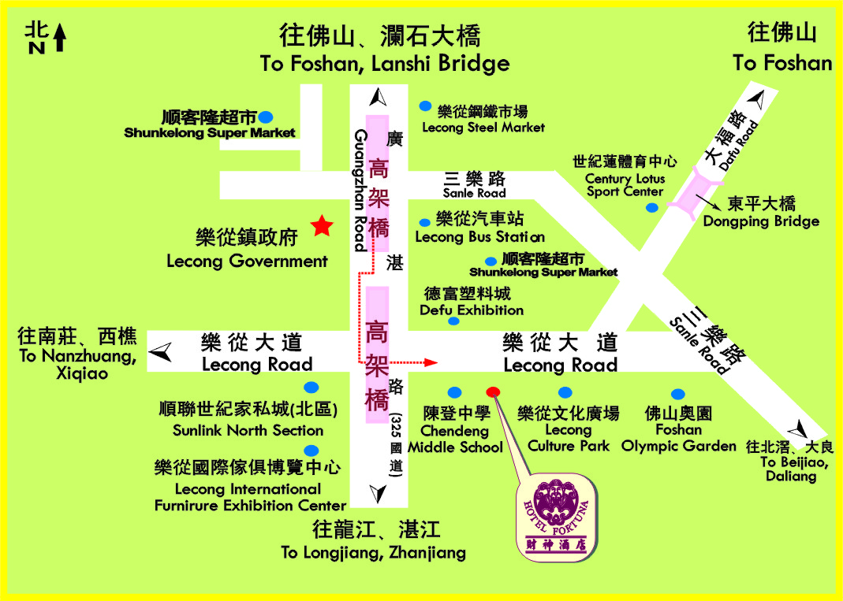
- All hotel bookings are subject to availability. Please make your hotel reservation before Nov.2, 2012. The reservation made after the deadline cannot be guaranteed.
- Credit Card is required to guarantee the booking. Room is reserved under the guest’s name. On the arrival day, guests should process in the hotel reception counter to check in.

Please return this form by Nov. 2, 2012 to
Ms. Nancy Wu / SEMI China

Tel: +86.21.5027.0909 ext. 271
Fax: +86.21.5027.4830
Email: nancy@semi.org.cn



