Center Paper Title Here

Center the Authors Names Here

Center the Affiliations Here
Center the City, States and Country Here
Center Phone and E-mail Address Here

Biography

Words of a biography limits to 200 words.

Abstract

One page paper is acceptable, but two pages paper increases your paper’s accepting rate. This short abstract here is a brief (50-80 words) synopsis of your paper. Its use is to provide a quick outline of your presentation, giving the reader an overview of the research. This is an important aspect of your paper, as it is this description that may attract the reader to continue and finish your full report. Keywords should be so chosen that they best describe the contents of the paper. In most cases, these words can be found in the title and abstract. Keywords, 5-10 in number, should be typed on the next line after the abstract.

Keywords—component; formatting; style; styling; insert (key words)
Introduction

These instructions give you basic guidelines for preparing your file for the CSTIC. The instructions assume that you have computer desktop publishing equipment with several fonts.
Your goal is to simulate, as closely as possible, the usual appearance of published papers CSTIC Digests. These instructions have been prepared in the preferred format. You may integrate graphics into text or include them in second page of this template. Papers submitted without supporting data will not be accepted.

How to Format the Page

A. Full-Size Format for your File

Prepare your file in full size format, 8 1/2” x 11” (215.9 mm x 279.4 mm) paper.

B. Fonts

The best results will be obtained if your computer word-processor has several font sizes. Do not use fonts smaller than the fonts specified in Table I. As an aid to gauging font size, 1 point is about 0.35 mm. Use a proportional, serif font such as Times or Dutch Roman.

Illustrations
TABLE I
FONT SIZES FOR CAMERA-READY PAPERS

Font Size | Bold | Italic | Text
10 |  |  | Main text, authors’ affiliations
10 | Yes |  | Headings, i.e. Abstract
12 |  |  | Authors’ names
14 | Yes |  | Paper title
10 |  | Yes | Sub-headings, i.e., Fonts
9 |  |  | References, table, table names, table captions, figure captions
8 |  |  | Footnotes, sub- and superscripts

Large figures and tables may span both columns. Figure captions should be below the figures; table captions should be above the tables. Try to place the figures and tables after their first mention in the text. Use the abbreviation (e.g., “Fig. 1”) even at the beginning of a sentence. All illustrations (pictures/photographs) should be clear. Do not use photocopies.

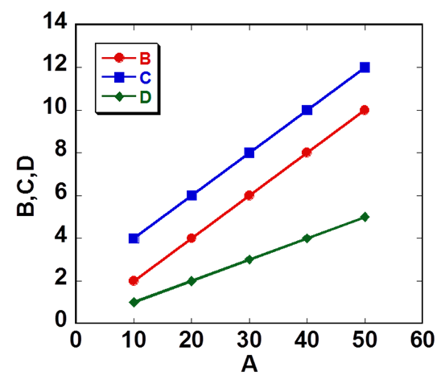
Fig.1. This is a good example of figure. Figure caption font size also should be more than 9pt. Reviewer cannot read too small font when it is printed out. Use dark color gives good contrast when it is printed out in black/white for paper review.

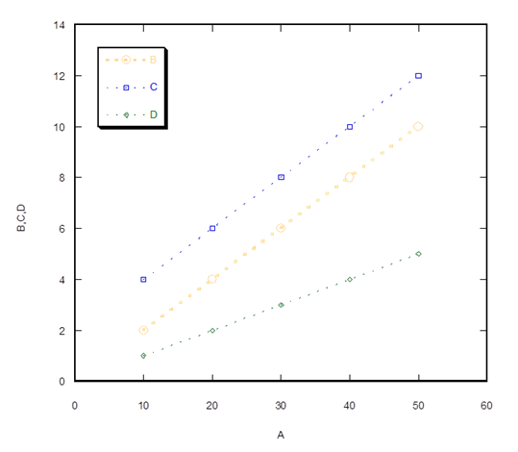

Fig. 2. This is a bad example. Small fonts, bright color, and thin line are difficult to read when it is printed out in black/white for paper review.
References
The template will number citations consecutively within brackets [1]. The sentence punctuation follows the bracket [2]. Refer simply to the reference number, as in [3]—do not use “Ref. [3]” or “reference [3]” except at the beginning of a sentence: “Reference [3] was the first ...” Number footnotes separately in superscripts. Place the actual footnote at the bottom of the column in which it was cited. Do not put footnotes in the reference list. Use letters for table footnotes. Unless there are six authors or more give all authors’ names; do not use “et al.”. Papers that have not been published, even if they have been submitted for publication, should be cited as “unpublished” [4]. Papers that have been accepted for publication should be cited as “in press” [5]. Capitalize only the first word in a paper title, except for proper nouns and element symbols. For papers published in translation journals, please give the English citation first, followed by the original foreign-language citation [6].

References

- B. Noble, and I. N. Sneddon, “On certain integrals of Lipschitz-Hankel type involving products of Bessel functions,” Phil. Trans. Roy. Soc. London, vol. A247, pp. 529–551, April 1955. (references)
- J. Clerk Maxwell, A Treatise on Electricity and Magnetism, 3rd ed., vol. 2. Oxford: Clarendon, 1892, pp.68–73.
- I. S. Jacobs and C. P. Bean, “Fine particles, thin films and exchange anisotropy,” in Magnetism, vol. III, G. T. Rado and H. Suhl, Eds. New York: Academic, 1963, pp. 271–350.
- K. Elissa, “Title of paper if known,” unpublished.
- R. Nicole, “Title of paper with only first word capitalized,” J. Name Stand. Abbrev., in press.
- Y. Yorozu, M. Hirano, K. Oka, and Y. Tagawa, “Electron spectroscopy studies on magneto-optical media and plastic substrate interface,” IEEE Transl. J. Magn. Japan, vol. 2, pp. 740–741, August 1987 [Digests 9th Annual Conf. Magnetics Japan, p. 301, 1982].
- M. Young, The Technical Writer’s Handbook. Mill Valley, CA: University Science, 1989.

